Purpose of Science Curriculum Maps
This map is meant to help teachers and their support providers (e.g., coaches, leaders) on their path to effective, college and career ready (CCR) aligned instruction and our pursuit of Destination 2025. It is a resource for organizing instruction around the TN State Standards, which define what to teach and what students need to learn at each grade level. The map is designed to reinforce the grade/course-specific standards and content—the major work of the grade (scope)—and provides suggested sequencing, pacing, time frames, and aligned resources. Our hope is that by curating and organizing a variety of standards-aligned resources, teachers will be able to spend less time wondering what to teach and searching for quality materials (though they may both select from and/or supplement those included here) and have more time to plan, teach, assess, and reflect with colleagues to continuously improve practice and best meet the needs of their students.
The map is meant to support effective planning and instruction to rigorous standards. It is not meant to replace teacher planning, prescribe pacing or instructional practice. In fact, our goal is not to merely “cover the curriculum,” but rather to “uncover” it by developing students’ deep understanding of the content and mastery of the standards. Teachers who are knowledgeable about and intentionally align the learning target (standards and objectives), topic, text(s), task,, and needs (and assessment) of the learners are best-positioned to make decisions about how to support student learning toward such mastery. Teachers are therefore expected--with the support of their colleagues, coaches, leaders, and other support providers--to exercise their professional judgment aligned to our shared vision of effective instruction, the Teacher Effectiveness Measure (TEM) and related best practices. However, while the framework allows for flexibility and encourages each teacher/teacher team to make it their own, our expectations for student learning are non-negotiable. We must ensure all of our children have access to rigor—high-quality teaching and learning to grade level specific standards, including purposeful support of literacy and language learning across the content areas.
Introduction

In 2014, the Shelby County Schools Board of Education adopted a set of ambitious, yet attainable goals for school and student performance. The District is committed to these goals, as further described in our strategic plan, Destination 2025. In order to achieve these ambitious goals, we must collectively work to provide our students with high quality, College and Career Ready standards-aligned instruction. The Tennessee State Standards provide a common set of expectations for what students will know and be able to do at the end of a grade. College and Career Ready Standards are rooted in the knowledge and skills students need to succeed in post-secondary study or careers. While the academic standards establish desired learning outcomes, the curriculum provides instructional planning designed to help students reach these outcomes. The curriculum maps contain components to ensure that instruction focuses students toward college and career readiness. Educators will use this guide and the standards as a roadmap for curriculum and instruction. The sequence of learning is strategically positioned so that necessary foundational skills are spiraled in order to facilitate student mastery of the standards.

Our collective goal is to ensure our students graduate ready for college and career. The standards for science practice describe varieties of expertise that science educators at all levels should seek to develop in their students. These practices rest on important “processes and proficiencies” with longstanding importance in science education. The Science Framework emphasizes process standards of which include planning investigations, using models, asking questions and communicating information. The science maps contain components to ensure that instruction focuses students toward college and career readiness. The maps are centered around four basic components: the state standards and framework (Tennessee Curriculum Center), components of the 5E instructional model (performance tasks), scientific investigations (real world experiences), and informational text (specific writing activities).

The Science Framework for K-12 Science Education provides the blueprint for developing the effective science practices. The Framework expresses a vision in science education that requires students to operate at the nexus of three dimensions of learning: Science and Engineering Practices, Crosscutting Concepts, and Disciplinary Core Ideas. The Framework identified a small number of disciplinary core ideas that all students should learn with increasing depth and sophistication, from Kindergarten through grade twelve. Key to the vision expressed in the Framework is for students to learn these disciplinary core ideas in the context of science and engineering practices. The importance of combining science and engineering practices and disciplinary core ideas is stated in the Framework as follows:
Standards and performance expectations that are aligned to the framework must take into account that students cannot fully understand scientific and engineering ideas without engaging in the practices of inquiry and the discourses by which such ideas are developed and refined. At the same time, they cannot learn or show competence in practices except in the context of specific content. (NRC Framework, 2012, p. 218)
To develop the skills and dispositions to use scientific and engineering practices needed to further their learning and to solve problems, students need to experience instruction in which they use multiple practices in developing a particular core idea and apply each practice in the context of multiple core ideas. We use the term “practices” instead of a term such as “skills” to emphasize that engaging in scientific investigation requires not only skill but also knowledge that is specific to each practice. Students in grades K-12 should engage in all eight practices over each grade band. This guide provides specific goals for science learning in the form of grade level expectations, statements about what students should know and be able to do at each grade level.

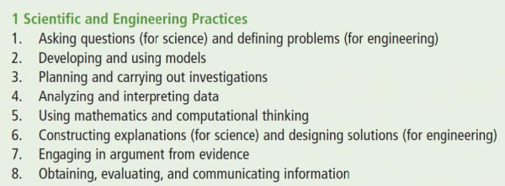

An instructional model or learning cycle, such as the 5E model is a sequence of stages teachers may go through to help students develop a full understanding of a lesson concept. Instructional models are a form of scaffolding, a technique a teacher uses that enables a student to go beyond what he or she could do independently. Some instructional models are based on the constructivist approach to learning, which says that learners build or construct new ideas on top of their old ideas. Engage captures the students’ attention. Gets the students focused on a situation, event, demonstration, of problem that involves the content and abilities that are the goals of instruction. In the explore phase, students participate in activities that provide the time and an opportunities to conducts activities, predicts, and forms hypotheses or makes generalizations. The explain phase connects students’ prior knowledge and background to new discoveries. Students explain their observations and findings in their own words. Elaborate, in this phase the students are involved in learning experience that expand and enrich the concepts and abilities developed in the prior phases. Evaluate, in this phase, teachers and students receive feedback on the adequacy of their explanations and abilities. The components of instructional models are found in the content and connection columns of the curriculum maps.

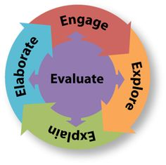

Science is not taught in isolation. There are commonalities among the practices of science (science and engineering), mathematics (practices), and English Language Arts (student portraits). There is an early focus on informative writing in ELA and science. There’s a common core in all of the standards documents (ELA, Math, and Science). At the core is: reasoning with evidence; building arguments and critiquing the arguments of others; and participating in reasoning-oriented practices with others. The standards in science, math, and ELA provide opportunities for students to make sense of the content through solving problems in science and mathematics by reading, speaking, listening, and writing. Early writing in science can focus on topic specific details as well use of domain specific vocabulary. Scaffold up as students begin writing arguments using evidence during middle school. In the early grades, science and mathematics aligns as students are learning to use measurements as well as representing and gathering data. As students’ progress into middle school, their use of variables and relationships between variables will be reinforced consistently in science class. Elements of the commonalities between science, mathematics and ELA are embedded in the standards, outcomes, content, and connections sections of the curriculum maps.
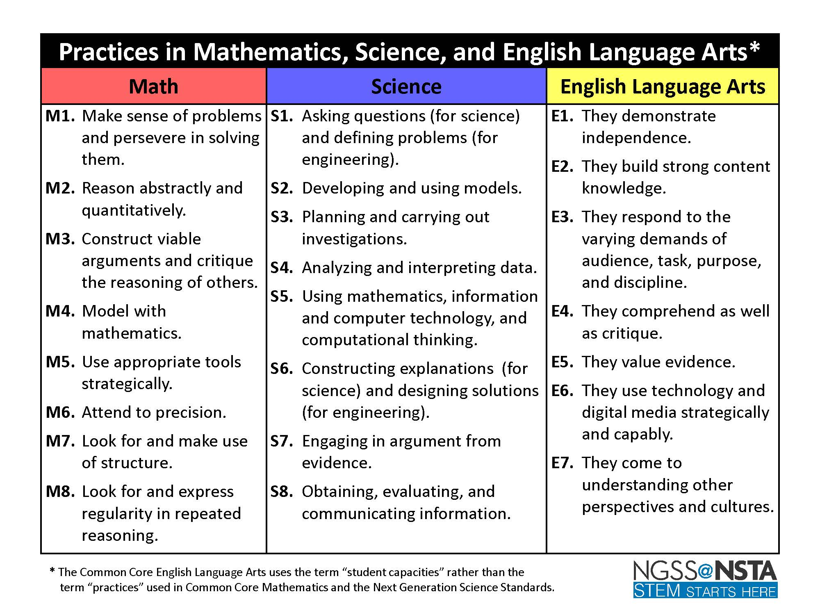

Science Curriculum Maps Overview

The science maps contain components to ensure that instruction focuses students toward college and career readiness. The maps are centered around four basic components: the state standards and framework (Tennessee Curriculum Center), components of the 5E instructional model (performance tasks), scientific investigations (real world experiences), informational text (specific writing activities), and NGSS (science practices)

At the end of the elementary science experience, students can observe and measure phenomena using appropriate tools. They are able to organize objects and ideas into broad concepts first by single properties and later by multiple properties. They can create and interpret graphs and models that explain phenomena. Students can keep notebooks to record sequential observations and identify simple patterns. They are able to design and conduct investigations, analyze results, and communicate the results to others. Students will carry their curiosity, interest and enjoyment of the scientific world view, scientific inquiry, and the scientific enterprise into middle school.

At the end of the middle school science experience, students can discover relationships by making observations and by the systematic gathering of data. They can identify relevant evidence and valid arguments. Their focus has shifted from the general to the specific and from the simple to the complex. They use scientific information to make wise decision related to conservation of the natural world. They recognize that there are both negative and positive implications to new technologies.

As an SCS graduate, former students should be literate in science, understand key science ideas, aware that science and technology are interdependent human enterprises with strengths and limitations, familiar with the natural world and recognizes both its diversity and unity, and able to apply scientific knowledge and ways of thinking for individual and social purposes.

.
How to Use the Science Curriculum Maps

Tennessee State Standards
The TN State Standards are located in the first three columns. Each content standard is identified as the following: grade level expectations, embedded standards, and outcomes of the grade/subject. Embedded standards are standards that allow students to apply science practices. Therefore, you will see embedded standards that support all science content. It is the teachers' responsibility to examine the standards and skills needed in order to ensure student mastery of the indicated standard.

Content
The performance tasks blend content, practices, and concepts in science with mathematics and literacy. Performance tasks should be included in your plans. These can be found under the column content and/or connections. Best practices tell us that making objectives measureable increases student mastery.

Connections
District and web-based resources have been provided in the Instructional Support and Resources column. The additional resources provided are supplementary and should be used as needed for content support and differentiation.

TN Standards | Learning Outcome |  |  | Content |  | Connections
Standard 5-Life Science- Biodiversity and Change-2 weeks
GLE 0407.5.2  Describe how environmental changes caused the extinction of various plant and animal species.  Scaffolded (Unpacked) Ideas  - Environmental changes occur naturally or are influenced by human activity.  - Environmental changes can have beneficial or detrimental consequences to living things.  - Drastic changes in the environment can reduce the number of individuals in a species and eventually lead to extinction.  - The extinction of a species means that it can no longer be found on earth.  - Some causes of the extinction of a particular species are known; some are not.  - The most common cause of extinction is habitat degradation or loss.  - Extinction of species is common.  - Most of the species that have ever lived no longer exist.  - Some species are only known from the fossil evidence that was left behind.  - Fossil evidence provides information about the relationship between species that have become extinct and ones that live today. | Essential Question  - What natural and human activities cause significant changes to the environment?  - What are the common causes of extinction?  - How can fossil evidence be used to draw comparisons between things that live today and animals and plants that no longer exist? |  |  | MacMillan/McGraw-Hill: A Closer Look Grade 4  Chapter 3 Lesson 1: Animal Adaptations p. 104-108  Chapter 3 Lesson 2: Plant Adaptations p. 114-116  Chapter 3 Lesson 3: Environmental Changes and Extinction p. 120-128  Labs and Investigations  - Explore: How can you compare matter? p. 249  - Quick Lab: pp. 265, 267, and 277  Analyzing an Ecosystem - What are ecological systems? This interactive activity adapted from the University of Alberta identifies the living and nonliving components of an animated ecosystem. Users are also invited to look at examples of mimicry, and identify which living things are producers and which are consumers. To help users complete the activity, key terms, including biotic and abiotic components, are defined.  Online resources  Moby Max : This is an excellent resource that provides cross- curriculum instruction through passages, interactive, and assessments.  Studyjams 11 Ecosystems Interactive Activities - Introduce and reinforce 11 important ecosystem-related topics, including food webs, symbiosis, and the water cycle, through these fun interactive activities  Ecology Interactive Simulator - In this lab you will get a chance to "build your own" ecosystem, and explore the effects of these interrelationships.  Types of Fossils - This interactive activity adapted from the University of California Museum of Paleontology explores the kinds of things we can learn from several types of fossils that scientists study.  Postcards from the Edge: Endangeres Species - This lesson plan allows students to develop an understanding of how humans impact the environment and can help cause species to become endangered. Students will learn about the animals and geography of their state. Problem solving skills help students determine the impact humans have made on the environment. This lesson correlates science with other curriculum's- social studies and language arts. Creating postcards described by this lesson would be useful for assessing the understanding of content at the end of the unit. Another strategy this site incorporates is the use of technology in researching and having students working in groups. This lesson can easily be adapted for use in the fourth grade.  Video resources  Ecosystem videos – this website has several small videos on Ecosystems.  The Grand Canyon: The Top Two Rock Layers - As you look at the sedimentary rocks at the Grand Canyon's rim, the top layers of visible rock are the youngest. In this video segment adapted from NOVA, a scientist explains what we know about the changing conditions in this location and the kinds of life they supported. The canyon's top layer, the Kaibab formation, records deposits laid down at the bottom of a shallow sea. The Coconino sandstone formation below it indicates that these watery conditions were preceded by much drier ones. This video is available in both English and Spanish audio, along with corresponding closed captions.  Becoming a Fossil - The remains of the vast majority of organisms that die are eaten by scavengers or decompose beyond recognition before they can be preserved. The conditions under which fossils can successfully form are unusual, and the odds that a fossil will then be exposed at the surface again, and discovered, are smaller still. Footage courtesy of NOVA: In Search of Human Origins  Fossils - Paleontologists seldom have the good fortune to find a complete set of remains of an ancient organism that is wholly intact. For instance, the discovery of a frozen woolly mammoth carcass, preserved hair and all, was a truly rare event. More common are discoveries of incomplete remains, such as bones, teeth, or hair, and trace fossils, such as footprints or leaf impressions, which indicate an organism once existed even though its actual remains have not been found. This still collage produced for Teachers' Domain reveals the variety of forms that fossils take, as well as examples of the kinds of life whose remains have been preserved |  | Academic Vocabulary  Hibernate, camouflage, mimicry, locomotion, adaptations, stimulus, tropism, fossil, environmental changes, endangered, extinct  Performance Tasks  - Website provides teachers with an opportunity for students to monitor their learning in connected multidisciplinary topics.  - Students will complete Ecosystems, a K12 Reader with text aligned with grade level expectations for ecosystems. (Practice 8/ Literacy.RI.3.3)  - Students will complete Fossil Guide, a guide that covers twelve fossils.  - Students will complete Ecosystems Performance Tasks during workstation time.  - Flow of Energy and Matter in a Garden Ecosystem What the students will learn  • Energy/ecological pyramid  • Roles in ecosystem  • Characteristics of predators, prey  • Hidden energy flow in the garden  • Loss of energy from one level to next  • Ways to care for the Earth  Students will read The Ecosystem of a Forest, a 1000L Lexile level passage about the forest ecosystem Distinguish among facts, reasoned judgment based on research findings, and speculation in a text.) (Practice 8/ Literacy.RI.3.3)  Students will read They're Back, an 890L Lexile level passage, where they will read about the history of the gray wolf. There is a paired text, Panthers in Peril. These texts have been paired because they both focus on endangered animals and measures taken to prevent their extinction Distinguish among facts, reasoned judgment based on research findings, and speculation in a text.) (Practice 8/ Literacy.RI.3.3)
Standard 9- Life Science-Matter 2 weeks
SPi 0407.9.1 Choose an appropriate tool for measuring specific physical property of matter.  GLE 0407.9.1 Collect data to illustrate that the physical properties of matter can be described with tools that measure weight, mass, length, and volume.  SPi 0407.9.2 Determine the mass, volume, and temperature of a substance or object using proper units of measurement.  GLE 0407.9.2 Explore different types of physical changes in matter.  SPi 0407.9.3 Interpret the causes and effects of a physical change of matter.  Scaffolded (Unpacked) Ideas  1. Substances have a variety of physical properties that can be measured using appropriate tools.  2. Although used almost interchangeably, mass and weight are different things.  3. The mass of something is a measure of how much matter it contains.  4. Mass is measured with a balance that compares a known amount of matter to the unknown amount of matter contained in an object.  5. The force of attraction between an object and the Earth is called its weight.  6. The weight of an object is measured with a scale.  7. Volume is the amount of three-dimensional space occupied by a substance.  8. The volume of an object or substance can be determined mathematically, by the amount of liquid it displaces, or by the size of the container it occupies.  9. Some physical properties of materials such as the ability to conduct heat and electricity, buoyancy, response to magnets, solubility, and transparency are not immediately apparent but can be described and measured.  10. Materials can be described and organized into groups according to their physical properties.  11. When matter undergoes a physical change, the original properties of the substance(s) remain unchanged. |  |  | Essential Question  - What tools are appropriate for measuring different physical properties of a material?  - What are some of the common methods for bringing about changes in the physical properties of a substance? | MacMillan/McGraw-Hill: A Closer Look Grade 4  Chapter 6 Lesson 1: p. 250-256  Chapter 6 Lesson 2: p. 260-269  Labs and Investigations  - Explore: How can you compare matter? p. 249  - Quick Lab: pp. 265, 267, and 277  Online resources  Measurement Games - This website lets the teacher select interactive games that allow the student to practice using customary and metric measurements. Although this website does not address every component of measurement in the GLE, the interactive activities can give students extra practice in measuring length and weight.  Moby Max : This is an excellent resource that provides cross- curriculum instruction through passages, interactive, and assessments.  What is Matter? – Interactive textbook review on Matter.  States of Matter – Interactive textbook on the states of matter.  States of Matter Interactive Game  Video resources  Matter Chatter song an interactive song about the states of matter.  The Magic School Bus Episode 19: Wet All Over – Miss Frizzle and her classroom take an adventure through the States of Matter.  Bill Nye the Science Guy: Phases of Matter – This episode is on the states ( phases) of matter |  | .  Academic Vocabulary  Length, mass, physical properties, volume, weight, temperature  Performance Tasks (Science practices 5 and 8)  - Website provides teachers with an opportunity for students to monitor their learning in connected multidisciplinary topics.  - Students will complete Forms of Matter, a K12 Reader article on the States of Matter.  - Calculating the Density of a Liquid - tutorial on the math involved plus sample questions (Science practice 5)  • Calculating Density of a Solid - tutorial on the math involved plus sample questions (Science practice 5)  • Converting Fahrenheit to Celsius - interactive problem from Annenberg (Science practice 5)  • Converting Length Measurements - use your knowledge of meters, centimeters and millimeters to answer questions to build a shed  • Finding the Mass of an Object - tutorial on using a triple-beam balance which includes questions to answer  • Finding the Volume of an Object - tutorial on using a graduated cylinder which includes questions to answer  • Platform Scales Addition - weigh several items and find the sum in hundredths of a gram  • Platform Scales Subtraction - weigh several items and find the difference in hundredths of a gram  • Teaching Measures - links to length, mass, or capacity activities and printables - good for using on an interactive whiteboard for a whole class activity  • Transparency Master - use this high quality picture of a block of metal on a triple beam balance as a review for your students  • Using a Graduated Cylinder - [L and mL] a whole class activity for reading a scale, estimating and converting between units  • Using a Graduated Cylinder - [mL only] a whole class activity for reading a scale, estimating and converting between units  • Using a Ruler - [15 cm ruler] a whole class activity for reading a ruler, estimating and converting between units  • Using a Ruler - [30 cm ruler] a whole class activity for reading a ruler, estimating and converting between units
Standard 10- Life Science – Energy 2 weeks
GLE 0407.10.1  Distinguish among heat, radiant, and chemical forms of energy.  GLE 0407.10.2  Explain how energy is transferred in a simple electrical circuit.  GLE 0407.10.3  Investigate how light travels and is influenced by different types of materials and surfaces.  Scaffolded (Unpacked) Ideas  - Energy exists in a variety of forms.  - Energy can be transferred from one place to another.  - Energy can be converted from one form to another.  - Light travels in straight lines until it strikes an object.  - When light strikes an object it can be absorbed, redirected, bounced back, or transmitted.  - All materials do not transmit light in the same manner.  - Light is reflected by a mirror and refracted by a lens.  - Shadows develop when light strikes a substance or object through which it cannot pass.  - When light passes through a prism it separates into the color spectrum.  - When light passes from one material to another at an angle it is often refracted, i.e., its direction changes. |  | Essential Questions  - What are the most common forms of energy?  - How is energy transferred and how can it change form?  - What are the basic principles that determine how light behaves? |  |  | MacMillan/McGraw-Hill: A Closer Look Grade 4  Chapter 6 Lesson3: pp.272-279  Chapter 6 Lesson 4: pp. 282-291  Labs and Investigations  Explore p. 273  Quick Lab p. 285 Angle of Reflection  Electricity Investigation This is a hands-on science investigation on electricity. Students learn  through the discovery method how electricity works. The student's natural curiosity and  sense of exploration will enable them to explore & learn on their own with little input  from the teacher.  Reflecting Rainbows - Students use compact discs (CD) to observe and explore how light is influenced by materials and surfaces. Simple directions are included to prompt students as they manipulate the disc to make different effects. Materials are easily obtainable. This activity is a good activity to engage students as they begin a study about how materials and surfaces influence how light behaves. In this activity, light is reflected causing a rainbow effect. This simple activity leads to students raising their own questions and informally exploring as they manipulate the CD in different amounts of light and move it in different directions.  Online Resources  Electricity and Energy Interactive Games  What is Energy? This is a quick snip it of information about ALL the different kinds of energy and their varied uses. This would be a great site for students to refer to as a study guide or reference page as they are learning and doing projects on energy. This site has an enormous amount of information and illustrations to show the varied states of energy and the producers of each type and how it is created and used. This site is laid out much like a book. Each chapter details a specific source of energy, in details, that students will find easy to read and understand. If there is a specific item you are looking for you can go directly to that topic without going through all the chapters. There is a tab at the top of the page that contains other resources including a great teacher resource page.  Electricity Resources – This website contains games about electricity.  Video Resources  BrainPop: Electrical Circuits  Bill Nye the Science Guy- Energy  Types of Circuits  Explaining an Electric Circuit | Academic vocabulary  Heat, light, radiant energy, chemical energy, solar energy, opaque, transparent, translucent, absorption, reflection, retraction, concave lens, convex lens  Performance Tasks  Students will read Electricity & Energy:, an 890L Lexile level passage on circuits (Distinguish among facts, reasoned judgment based on research findings, and speculation in a text.) (Practice 8/ Literacy.RI.3.3)  Students will read Electricity & Energy: The Light Bulb, a 750L Lexile level passage that talks about the history of the light bulb. Distinguish among facts, reasoned judgment based on research findings, and speculation in a text.) (Practice 8/ Literacy.RI.3.3)  - Students will read Electricity & Energy: Energy, a 780L Lexile level passage that discusses forms of energy.(Practice 8/ Literacy.RI.3.3)  - Electricity games – Neok12 has activities, lessons, games, quizzes, and videos on Electricity.  - Students will read Light Bounces, a 720L Lexile level passage describing how light travels. It is specified as 3rd Grade read, but it can be used in fourth grade. (Practice 8/ Literacy.RI.3.3)  - Broken Pencil - animation and explanation of the science behind an interesting demonstration  - Image Formation for Plane Mirrors - good animation showing where an image is formed in a mirror  - Law of Reflection - good animation from Multimedia Physics Studio  - Lenses - an interactive optics bench that allows students to investigate the effects of object location on the characteristics of an image - from Shockwave Physics Studios  - Reflection and the Ray Model of Light - chapter outline of a set of explanations about reflection - four lessons, each with multiple parts  - Refraction - investigate the refraction and reflection of light at a boundary with this activity from Shockwave Physics Studios (Science Practice 3: The student can engage in scientific questioning to extend thinking or to guide investigations)

TN Standards | Learning Outcome | Content | Connections
Standard 11- Life Science – Motion- 3 weeks
GLE 0407.11.1 Recognize that the position of an object can be described relative to other objects or a background  GLE 0407.11.2 Design a simple investigation to demonstrate how friction affects the movement of an object.  GLE 0407.11.3 Investigate the relationship between the speed of an object and the distance traveled during a certain time period.  Scaffolded (Unpacked) Ideas  - An object’s position can be described by its location relative to other objects or a background.  - Forces can cause an object to change speed and direction of movement.  - The amount of change in motion of an object is determined by the strength of the force and the mass of the object.  - An object’s speed is the distance the object travels over a period of time.  - When surfaces that are in contact move relative to each other, friction results.  - Friction is the force between moving objects that opposes their relative motion and produces heat.  - Data about the speed and position of an object as a function of time can be illustrated with a graph.  . | Essential Questions  - What factors determine the speed and direction of motion of an object?  - How are the elements of speed, position, and time used to describe the motion of an object? | MacMillan/McGraw-Hill: A Closer Look Grade 4  Explain:  Labs and Investigations  Explore: How can you describe an object’s position p. 303  Explore: How fast move? p. 311  Interactive Friction investigation – this interactive investigation allows different materials to use to show friction affects the movement of a car.  Streetlife Car Constructor – Become an engineer and build your own car. After building your car, go to the Streetlife test track to test your car through various surfaces.  Online resources  Describing Motion with Words: Distance and Displacement - [Lesson 1] this lesson from the Physics Classroom includes a quick quiz section and two check your understanding" questions  Forces in Action – this interactive activity shows force affects the movement of an object.  Interactive Force an motion games – This website has games, diagrams, activities, and other things to use on force and motion.  The Science of Heat – this website can be used as an introduction to heat.  Video Resources  .  Force and Motion videos – courtesy of Watch Learn Know  Different Sources of Energy – this video discusses different sources of energy that aligns with this standard.  What is Energy? video – this short video talks about the types of energy  Heat Temperature and Energy – this video will help students understand heat energy (thermal). | Academic vocabulary  Position, distance, speed, velocity, acceleration, inertia, force, friction  Performance Tasks  - Forces and Action - students can change variables and collect data as they investigate factors that influence the motion of a toy truck.  - Average vs. Instantaneous Speed - this animation shows one of the factors that influences motion  - Design a Roller Coaster - Try your hand at designing your own roller coaster. You will be building a conceptual coaster using the physics concepts that are used to design real coasters. You won't need to compute any formulas  - Mobymax and Power My Learning can be utilized in this standard.

