Introduction

In 2014, the Shelby County Schools Board of Education adopted a set of ambitious, yet attainable goals for school and student performance. The District is committed to these goals, as further described in our strategic plan, Destination 2025. In order to achieve these ambitious goals, we must collectively work to provide our students with high quality, College and Career Ready standards-aligned instruction. The Tennessee State Standards provide a common set of expectations for what students will know and be able to do at the end of a grade. College and Career Ready Standards are rooted in the knowledge and skills students need to succeed in post-secondary study or careers. While the academic standards establish desired learning outcomes, the curriculum provides instructional planning designed to help students reach these outcomes. The curriculum maps contain components to ensure that instruction focuses students toward college and career readiness. Educators will use this guide and the standards as a roadmap for curriculum and instruction. The sequence of learning is strategically positioned so that necessary foundational skills are spiraled in order to facilitate student mastery of the standards.
Our collective goal is to ensure our students graduate ready for college and career. The standards for science practice describe varieties of expertise that science educators at all levels should seek to develop in their students. These practices rest on important “processes and proficiencies” with longstanding importance in science education. The Science Framework emphasizes process standards of which include planning investigations, using models, asking questions and communicating information. The science maps contain components to ensure that instruction focuses students toward college and career readiness. The maps are centered around four basic components: the state standards and framework (Tennessee Curriculum Center), components of the 5E instructional model (performance tasks), scientific investigations (real world experiences), and informational text (specific writing activities).
The Science Framework for K-12 Science Education provides the blueprint for developing the effective science practices. The Framework expresses a vision in science education that requires students to operate at the nexus of three dimensions of learning: Science and Engineering Practices, Crosscutting Concepts, and Disciplinary Core Ideas. The Framework identified a small number of disciplinary core ideas that all students should learn with increasing depth and sophistication, from Kindergarten through grade twelve. Key to the vision expressed in the Framework is for students to learn these disciplinary core ideas in the context of science and engineering practices. The importance of combining science and engineering practices and disciplinary core ideas is stated in the Framework as follows:
Standards and performance expectations that are aligned to the framework must take into account that students cannot fully understand scientific and engineering ideas without engaging in the practices of inquiry and the discourses by which such ideas are developed and refined. At the same time, they cannot learn or show competence in practices except in the context of specific content. (NRC Framework, 2012, p. 218)
To develop the skills and dispositions to use scientific and engineering practices needed to further their learning and to solve problems, students need to experience instruction in which they use multiple practices in developing a particular core idea and apply each practice in the context of multiple core ideas. We use the term “practices” instead of a term such as “skills” to emphasize that engaging in scientific investigation requires not only skill but also knowledge that is specific to each practice. Students in grades K-12 should engage in all eight practices over each grade band. This guide provides specific goals for science learning in the form of grade level expectations, statements about what students should know and be able to do at each grade level.
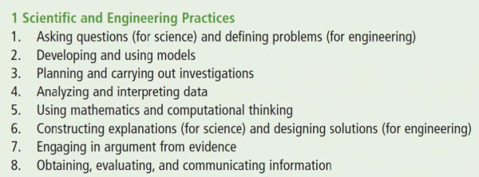

An instructional model or learning cycle, such as the 5E model is a sequence of stages teachers may go through to help students develop a full understanding of a lesson concept. Instructional models are a form of scaffolding, a technique a teacher uses that enables a student to go beyond what he or she could do independently. Some instructional models are based on the constructivist approach to learning, which says that learners build or construct new ideas on top of their old ideas. Engage captures the students’ attention. Gets the students focused on a situation, event, demonstration, of problem that involves the content and abilities that are the goals of instruction. In the explore phase, students participate in activities that provide the time and an opportunities to conducts activities, predicts, and forms hypotheses or makes generalizations. The explain phase connects students’ prior knowledge and background to new discoveries. Students explain their observations and findings in their own words. Elaborate, in this phase the students are involved in learning experience that expand and enrich the concepts and abilities developed in the prior phases. Evaluate, in this phase, teachers and students receive feedback on the adequacy of their explanations and abilities. The components of instructional models are found in the content and connection columns of the curriculum maps.

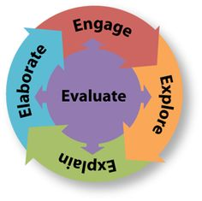

Science is not taught in isolation. There are commonalities among the practices of science (science and engineering), mathematics (practices), and English Language Arts (student portraits). There is an early focus on informative writing in ELA and science. There’s a common core in all of the standards documents (ELA, Math, and Science). At the core is: reasoning with evidence; building arguments and critiquing the arguments of others; and participating in reasoning-oriented practices with others. The standards in science, math, and ELA provide opportunities for students to make sense of the content through solving problems in science and mathematics by reading, speaking, listening, and writing. Early writing in science can focus on topic specific details as well use of domain specific vocabulary. Scaffold up as students begin writing arguments using evidence during middle school. In the early grades, science and mathematics aligns as students are learning to use measurements as well as representing and gathering data. As students’ progress into middle school, their use of variables and relationships between variables will be reinforced consistently in science class. Elements of the commonalities between science, mathematics and ELA are embedded in the standards, outcomes, content, and connections sections of the curriculum maps.
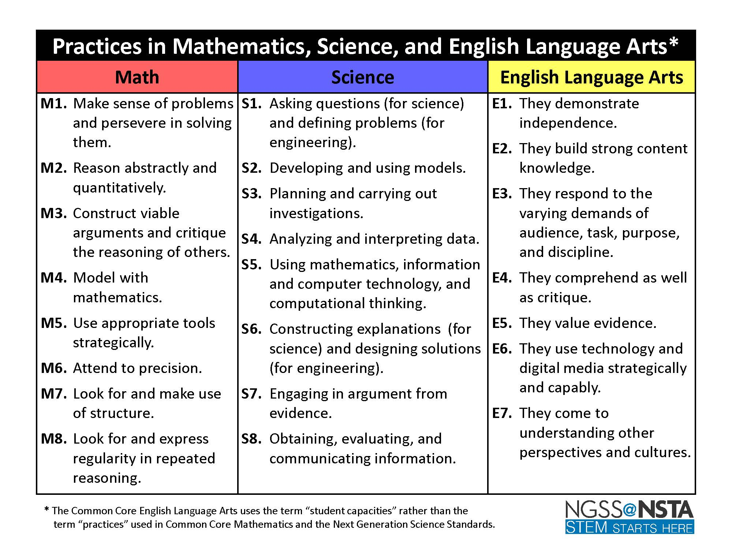

Science Curriculum Maps Overview
The science maps contain components to ensure that instruction focuses students toward college and career readiness. The maps are centered around four basic components: the state standards and framework (Tennessee Curriculum Center), components of the 5E instructional model (performance tasks), scientific investigations (real world experiences), informational text (specific writing activities), and NGSS (science practices).

At the end of the elementary science experience, students can observe and measure phenomena using appropriate tools. They are able to organize objects and ideas into broad concepts first by single properties and later by multiple properties. They can create and interpret graphs and models that explain phenomena. Students can keep notebooks to record sequential observations and identify simple patterns. They are able to design and conduct investigations, analyze results, and communicate the results to others. Students will carry their curiosity, interest and enjoyment of the scientific world view, scientific inquiry, and the scientific enterprise into middle school.

At the end of the middle school science experience, students can discover relationships by making observations and by the systematic gathering of data. They can identify relevant evidence and valid arguments. Their focus has shifted from the general to the specific and from the simple to the complex. They use scientific information to make wise decision related to conservation of the natural world. They recognize that there are both negative and positive implications to new technologies.

As an SCS graduate, former students should be literate in science, understand key science ideas, aware that science and technology are interdependent human enterprises with strengths and limitations, familiar with the natural world and recognizes both its diversity and unity, and able to apply scientific knowledge and ways of thinking for individual and social purposes.

Purpose of the Science Curriculum Maps
The Shelby County Schools curriculum maps are intended to guide planning, pacing, and sequencing, reinforcing grade level expectations of the grade/subject. Curriculum maps are NOT meant to replace teacher preparation or judgment; however, they serve as a resource for good first teaching and making instructional decisions based on best practices, and student learning needs and progress. Teachers should consistently use student data differentiate and scaffold instruction to meet the needs of students. The curriculum maps should be referenced each week as you plan your daily lessons, as well as daily when instructional support and resources are needed to adjust instruction based on the needs of your students.

How to Use the Science Curriculum Maps
Tennessee State Standards
The TN State Standards are located in the first three columns. Each content standard is identified as the following: grade level expectations, embedded standards, and outcomes of the grade/subject. Embedded standards are standards that allow students to apply science practices. Therefore, you will see embedded standards that support all science content. It is the teachers' responsibility to examine the standards and skills needed in order to ensure student mastery of the indicated standard.

Content
The performance tasks blend content, practices, and concepts in science with mathematics and literacy. Performance tasks should be included in your plans. These can be found under the column content and/or connections. Best practices tell us that making objectives measureable increases student mastery.
Connections
District and web-based resources have been provided in the Instructional Support and Resources column. The additional resources provided are supplementary and should be used as needed for content support and differentiation.

State Standards | Embedded Standards | Outcomes | Content | Connections
Standard 6 – The Universe – 3 weeks
GLE 0607.6.3 Explain how the positional relationships among the earth, moon, and sun control the length of the day, lunar cycle, and year.  GLE 0607.6.4 Describe the different stages in the lunar cycle.  GLE 0607.6.5 Produce a model to demonstrate how the moon produces tides.  Scaffolded (Unpacked) ideas  - The sun occupies the center of a system that consists of planets and their moons.  - The sun produces light that radiates out into space.  - Earth is the third planet from the sun.  - The earth completes one revolution around the sun every year.  - The moon rotates on its axis once each day.  - A lunar cycle is about a month long and occurs while the moon completes one revolution around the earth.  - The moon appears bright because of the sunlight that is reflected from its surface.  - The moon appears to have different shapes from day to day throughout a lunar cycle.  - The apparent shape of the moon depends on how much of its surface is reflecting sunlight. | GLE 0607.Inq.3 Synthesize information to determine cause and effect relationships between evidence and explanations.  GLE 0607.Inq.4 Recognize possible sources of bias and error, alternative explanations, and questions for further exploration.  GLE 0607.Inq.5 Communicate scientific understanding using descriptions, explanations, and models. | Distinguish among a day, lunar cycle, and year based on the movements of the earth, sun, and moon.  Explain the different phases of the moon using a model of the earth, moon, and sun.  Predict the types of tides that occur when the earth and moon occupy various positions. | Tennessee Holt Science and Technology TE, Chapter 8 Formation of the Universe, p. 238-241;Chapter 10 Earth, Moon and Sun, p. 287– 301  Glencoe Tennessee Science Grade 6 TWE, Chapter 6 The Sun-Earth-Moon System, p. 164-193  Recommended activities:  (For labs and investigations, allow students to identify independent and dependent variables and controls, what tools are needed to do the gathering, how measurements will be recorded, provide evidence to support explanations or solutions and how many data are needed to support a claim.)  Science Teacher’s Activity a Day:  - Light-years pg. 202  - The gyroscopic effect pg. 206  - Space shuttle orbits pg. 207  - Gravity and space instruments pg. 209  - Orbiting the sun pp. 218-219  - Surviving on the moon pg. 221  Labs:  Oreo Moon Phase Activity – Simulate the Moon Phases with Oreo cookies activity and data sheet  Informational text:  Living on the moon – Readworks article Lexile level of 1040L  Climbing space – article from Readworks Lexile level 1420L  Cold faithful – article from Readworks Lexile level 1170L  The Explorers - Neil Armstrong – article from newsEla Lexile level 940L  New Imax movie – article from newEla Lexile level 980L  San Francisco – article from newsEla Lexile level 970L  Videos:  What causes the tides? Nova video explaining the cause of tides.  Tides This web site provides multimedia, lesson plans, real world data, articles and background information on tides, as well as career profiles interviews  Bay of Fundy Tides – Video and information on the tides at the Bay of Fundy – highest tides in the world  Tides – interactive video on from Study jams  Lessons:  Sun Lesson Plan- The purpose of this lesson is to introduce students to our local star, the sun, especially its structure and its features such as sun-spots, magnetic fields, and solar flares.  Teaching moon phases – lesson that includes literacy and hands on strategies  Additional resources:  Moon Phases - This activity allows you to "drag" pictures of different phases of the moon to their correct places in lunar cycles. There are calendars that include illustrations of the phases of the moon for most days, and the challenge is for you to complete the calendars by filling them with the correct moon phases for all days.  Predicting the Tides Students use data to predict the next tides.  Class zone animation on revolution – revolution animation  Astronomy Animations – Animations on seasons, moon phases and tides  Wonderville Interactive website on moon phases.  Moon Phases Simulator Simulates movement of the moon around Earth.  Space Lessons Links to various lessons plans about space.  Scale model of the solar system - It's hard to image the vast distances in the universe. We can image twelve inches or ten feet, but 93 million miles is a bit hard to comprehend. Here's an interesting way to get an idea of the distances between the planets and Sun using toilet paper.  Earth, moon, and sun – Prezi slideshow on the movement of the Earth-Sun-Moon system  Data, models, and visualizations – This site has animations, photos, and illustrations to explain phenomena of earth, sun, moon, and tides  Assessments:  Earth, sun, and moon – 23 multiple choice questions  Test review – questions on the earth, moon, and sun  Preview test – this assessment features thirty five items on the earth, moon, sun, and seasons  Tides quiz – 10 multiple choice items designed by Quizmaker  Moons, seasons, tides – multiple choice review that has varied question prompts  Community connections  Pink Palace:  Sharpe planetarium: Earth, Moon, & Sun; Firefall (ends Nov. 2016); Life: A Cosmic Story  In the classroom (Pink Palace Museum Outreach) Suitcase exhibit (free): Sun& Moon, Planets & the Solar System  Science fair/challenge ideas:  NASA space place – explore earth and space  Moon project – projects and experiments | Academic vocabulary: cosmology, big bang theory, tide, tidal range, spring tide, neap tide, light reflection, lunar cycle, lunar eclipse, solar eclipse, solar system  **(For academic vocabulary, use one of Marzano’s high yield instructional strategies)**  Performance task: You are an Earth expert, who is currently working with NASA on a special project involving communicating with extra-terrestrial life forms. Your audience is NASA astronauts and extra-terrestrial life forms. Prepare a written report on reasons for day and night on earth including diagrams, models, graphs, and/or illustrations. You may include additional information that you believe would be helpful to the alien visitor. (Science Practice/Literacy RST . RST.6-8.8)  Performance task: . In your scientific journal, write daily classroom observations in your notebooks. Track the hours of daylight and hours of darkness. Use the newspaper (weather page) as a reference tool. Make predictions and observations based on data that you have collected. (Science Practice/Literacy RST CCSS.ELA-LITERACY.RST.6-8.9)  Performance task: Introduce the students to an 8 x11 piece of card stock, a wooden dowel, a compass, science notebook, and a pencil. Conduct an explore session for students on a sunny day by facilitating them through the raising of questions for further investigation related to the learning outcomes of this standard. Students will choose a question for further investigation and conduct their investigation. When the investigation is completed, students will share out their findings with the class. Students should synthesize their own learning in their science notebook. (Science Practice/Literacy RST)  Performance task:. Build a model to show day and night. Teacher and students will brainstorm and determine which Styrofoam ball will represent the sun and earth and should be able to defend their reasoning based on prior knowledge. The teacher will provide markers to the students and ask then to color the sun (large ball) yellow and color the earth (medium ball) blue. Each ball should be completely colored. Afterwards, tell the students that the earth rotates on its axis once every twenty four hours. Using the sun and earth models, the students will be given time to explore why/how we experience day and night. At the end of this inquiry, teacher and students will synthesize information. (Science Practice/Literacy RST)  Performance task: Create a classroom chart that will show the appearance of the moon on a daily basis using websites as references. Students should make observations in their journals and can add graphics to their observational notes. (Science Practice/Literacy RST)  Performance task: Provide students with ‘phases of the moon’ sheet. Students will work in pairs. Teacher will instruct students to write the predicted date that the moon phase will appear in the bottom right hand corner of each moon block. The students at this point will meet their science partner and will discuss their predictions. Students will justify their predictions in their science notebooks. Sample questions include: Why is this happening? Show me how that relates to what we’re studying? How do you know that? What do you see, notice, about..? Where have you seen this pattern before? What does this remind you of? (Science Practice/Literacy RST)  Performance task: Students and teacher will work together for the first part of this experiment. Teacher should mark the floor with masking tape to show the path that they will follow. There should be a total of 8 marks on the floor. The teacher will place a bright light in the center of a darkened room. Make the room as dark as possible. Using their own small moon Styrofoam ball, the entire class should form a circle around the light. This circle should be as tight as possible but still allow each student to turn around with one arm extended. All students should face the light (sun) and hold their ball directly in front of his body or slightly above his head. Observe what portion of the side of the moon facing you is illuminated by the sun. Now turn 45 degrees to the left and make the same observation. Continue to make a 45-degree turn until you are once again facing the sun. Students and teacher will synthesize the information by discussing the following questions and by reflecting in their notebook: How much of the illuminated part of the moon could you see when you are facing the sun? How much of the illuminated part of the moon could you see after each turn? Whether you could see it or not, how much of the ball’s surface area was always illuminated? (NGSS Practice/Literacy RST)  Performance task: Teacher will provide students with a copy of the Lunar phase matching game. Each student will cut out the photo column of the page and put it aside. Next, they will paste the remainder of the Lunar phase matching paper into their science notebooks. Students will then cut individual photo of the moon phases and will begin to manipulate the photos. Working in pairs, students will begin to match the photos with the phase name and description. Using their data collection sheets, the students will verify the accuracy of their matches against their collected data. Students will then paste the corresponding photo to the phase name and description. (Science Practices/ Literacy RST)  Performance task: (Science Practice/Literacy RST) Students and teacher will meet to synthesize the data that has been gathered from the previous tasks. Teacher will post chart paper throughout the rom with the following headings: new moon, crescent, first quarter, waxing gibbous, full moon, waning gibbous, third/last quarter, and waning crescent. Teachers will share information with the students such as waning=losing light to the left, waxing=gaining light to the left, gibbous=3/4, and crescent=silver. Teacher will say” Before we draw the phases of the moon today, what can you tell me about the following phases of the moon’? After students have had the chance to visit all 8 charts, the group will review information and the teacher will clarify for accuracy. Teacher will hand out phases of the moon for each student. Students will need a pair of scissors, glue, and construction paper. Each student will be asked to begin with the new moon and to arrange the phases in order with names and descriptions. Earth, moon and sun pg. 11  Performance task: Choose two different parts of the world to investigate in greater detail. Graph five days of data, including tidal height versus time in hours.  - When was the highest tide?  - When was the lowest tide?  - What are two main factors that cause tides on Earth? (Science practice/Literacy RST
Standard 6 –The Universe – 3 weeks
GLE 0607.6.6 Illustrate the relationship between the seasons and the earth-sun system.  GLE 0607.6.7 Describe the causes of lunar and solar eclipses.  Scaffolded (Unpacked) ideas  - Seasons on earth depend on the relationship within the sun, earth, and moon system.  - Different seasons are characterized by different climate conditions.  - Eclipses occur when one celestial object moves into the shadow of another and partially or fully obscures it from being seen.  - A solar eclipse happens when the moon travels between the sun and the earth, blocking the sun’s light from reaching the earth during the day.  - During a lunar eclipse the moon moves into the shadow of the earth during nighttime and blocks the view of the moon from the earth. | GLE 0607.Inq.3 Synthesize information to determine cause and effect relationships between evidence and explanations.  GLE 0607.Inq.4 Recognize possible sources of bias and error, alternative explanations, and questions for further exploration.  GLE 0607.Inq.5 Communicate scientific understanding using descriptions, explanations, and models. | Use a diagram that shows the positions of the earth and sun to explain the four seasons.  Explain the difference between a solar and a lunar eclipse. | Tennessee Holt Science and Technology TE, Chapter 10 Earth, Moon and Sun, p. 287– 301  Glencoe Tennessee Science Grade 6 TWE, Chapter 6 The Sun-Earth-Moon System, p. 164-193  Recommended activities:  (For labs and investigations, allow students to identify independent and dependent variables and controls, what tools are needed to do the gathering, how measurements will be recorded, provide evidence to support explanations or solutions and how many data are needed to support a claim.)  Science Teacher’s Activity a Day:  - Solar eclipse p.222  - Astrolabe p. 223  - Lunar surface regolith p. 227  Labs:  Seasons – activity includes three parts  Moon phases and eclipse – series of seven lab activities with reflective questions at the end  Informational text:  Cloze Reading - Tides, Eclipses, Day and Night, and Seasons  Earth Sun Geometry – four page reader with accompanying questions  Seasons – text and writing prompts from the space cycle  Videos:  Earth, Moon, and Sun - A video about the relative positions of the Earth Moon and Sun  Earth, sun, and moon phases - A four minute video about the relative positions of the Earth Moon and Sun  Total solar eclipse - This video is available in both English and Spanish audio, along with corresponding closed captions.  Lunar eclipse – Four-minute video on What's the difference between a solar and lunar eclipse?  Lessons:  Solar and lunar eclipse – curricula from Carolina that includes inquiries and informational text  Modeling eclipses – Modeling activity used to simulate eclipses  Additional resources:  Astronomy Animations – Animations on seasons, moon phases and tides  Seasons – activities from the Lunar and Planetary Institute  Assessments:  Sun-earth-moon system –self check quiz  Sun-earth-moon – chapter review questions  Eclipse – standardized test practice  Community connections:  Local meteorologists  Science fair/challenge ideas:  Does the moon rotate? Make a 3-dimensional model of the Earth and moon  Build a moon habitat - You can be a Moon explorer too. Practice by building your own Moon habitat. Pretend you are an astronaut working with your teammates on the Moon to build your new home. | Academic vocabulary – day, equinox, solstice, phase, lunar cycle, eclipse, seasons, solar eclipse, solar system  Performance task: Out of this World – Using this guide, the teacher will help students understand that the Sun, planets, and the planets’ moons are parts of the solar system, and that the work done by astronauts and astronomers helps others know more about the solar system. This activity will allow students to be active participants as they further explore the concept of the solar system. (Science practice/Literacy RST  Performance task: Students will draw a diagram of the relative positions of the sun, earth and moon during a solar and a lunar eclipse (Science practice/Literacy RST)  Performance task: Instruct groups of three students to assign roles to one another (Sun, Earth, and Moon) and to model a lunar and solar eclipse. (Science practice/Literacy RST)  Performance task: Reasons for Seasons – complete the task beginning at page 3. Perform the demonstration, and record observations in your logbook. (Science practice/Literacy RST)  Performance task: Illustrative mathematics - At which point in the earth's orbit are the days in the United States shortest? At which point in the earth's orbit are the days in the United States the longest? Explain. Indicate in the picture that sections of the orbit correspond to the four seasons (winter, spring, summer, fall) in the United States. Justify your choices. (Science practice/Literacy RST)
Standard 8 – The Atmosphere – 3 weeks
GLE 0607.8.3  Investigate the relationship between currents and oceanic temperature differences.  GLE 0607.8.4  Analyze meteorological data to predict weather conditions.  Scaffolded (Unpacked) ideas  - Ocean currents are caused by the sun.  - At the equator evaporation exceeds condensation.  - Excessive evaporation makes sea water more salty and dense causing it to sink.  - At polar regions, excessive condensation makes water less dense and salty causing it to remain at the surface.  - Such temperature-related, density differences cause massive movements of ocean water.  - Currents have an impact on the climate of a region.  - Warm water currents make the surrounding areas warmer than expected, cold water currents produce the opposite effect.  - Differential heating and cooling of land and water result in onshore and offshore breezes that affect local weather conditions in coastal areas.  - Meteorological data display patterns that can be used to predict future weather conditions. | GLE 0607.Inq.1 Design and conduct open-ended scientific investigations.  GLE 0607.Inq.5 Communicate scientific understanding using descriptions, explanations, and models. | Determine the conditions under which clouds form.  Analyze the movement of two converging air masses with different temperature and humidity conditions  Analyze data to identify events associated with heat convection in the atmosphere, including cloud formation, winds, and storms  Analyze weather maps and use data to write a current weather report and weather forecast. | Tennessee Holt Science and Technology Chapter 6 The Atmosphere pp. 150-179  Glencoe Tennessee Science Grade 6 TWE, Chapter 10, Atmosphere, pp. 294-321  Tennessee Holt Science and Technology TE, Chapter 6: Section 2 Atmospheric Heating and Section 3  Global Winds and Local Winds p. 156-165  Chapter 7: Section 1 Water in the Air, Section 2 Air Masses and Fronts p. 184-197, and Section 4 Forecasting the Weather p. 206-209  Glencoe Tennessee Science Grade 6 TWE, Chapter 10 Atmosphere, p. 294-321  Chapter 11 Weather, p. 322-342  Recommended activities:  (For labs and investigations, allow students to identify independent and dependent variables and controls, what tools are needed to do the gathering, how measurements will be recorded, provide evidence to support explanations or solutions and how many data are needed to support a claim.)  Science Activity a Day:  - Ocean currents p. 169  - Temperature inversions p. 186  - Cloud formation p. 187  - Warm air rises p. 188  Labs:  Cloud in a bottle – investigation with reflecting questions  Weather station – activity with information on how to make a weather station  Informational text:  Read the Global water crisis for science understanding- Standard 8: The Atmosphere (included in the ELA maps)  Clouds – article that emphasizes reading comprehension  Videos:  Role of ocean currents -This ThinkTV segment demonstrates that ocean surface currents have a major impact on regional climate around the world, and explores the role of these currents in the creation of climate zones.  Gathering data – When analyzing weather forecasts, students will need to think about where to find the data they need.  Lesson:  Do ocean surface currents influence climate? – plan includes activities with the scientific method embedded  Additional resource:  Climate data - Find information about New Zealand's temperature record and climate change in our information and resources section.  Assessments:  Ocean science sequence – booklet contains sample assessments for teachers to integrate during lessons  Community connections  - Memphis Light, Gas, and Water  - Local news stations  - Meteorologists  - Clean Memphis  - City of Memphis  - Memphis International Airport  - Water on Wheels (University of Memphis)  Science challenge/project ideas:  Make your own cloud – experiment to deepen understanding of clouds | Academic vocabulary: anemometer, atmospheric convection, barometer, climate change, hygrometer, meteorological data, ocean current, psychometer, wind, tides  Performance task: Create a weather forecast and explain the effects of heat on weather patterns, wind systems, tornados, thunderstorms, and hurricanes. (Science Practice/Literacy RST)  Performance task: Role: You are a meteorologist that is producing a TV special on weather geared to 6th grade students. (Science practice/Literacy RST)  Audience: Executives for the Weather Service and 6th grade students.  Situation: National test scores in science have indicated that teachers need resources to help them teach the National Standards on climate and weather. You will develop a teaching module that includes background information, labs and activities that will help teachers and students understand the National Standards.  Product: You will create a booklet with content information on climate and weather. You will need to explain how the tilt of the Earth affects the amount of solar energy, which will in turn affect the climate of an area. You will also explain how the heating of land and water affects weather patterns and weather events such as tornados, thunderstorms, and hurricanes. In addition to the booklet you will develop a weather forecast to demonstrate how this information helps to predict and forecast weather. Rubric – p. 6 (Science Practice/Literacy RST)  Performance task: Students write their initial ideas about climate change. Using cards, groups create a timeline of major changes in Earth’s atmosphere throughout history, gaining a sense of deep time and rate of change for those events. (Science Practice/Literacy RST)  Performance task: Students discuss a weather pattern in Costa Rica and discover connections between the ocean and atmosphere. They observe a “cloud-in-a-jar” and write about evaporation and condensation in terms of water molecules and heat energy. (Science Practice/Literacy RST)

