Even Pay Explanation for Salaried Employees
For salaried employees, the pay period dates listed on the pay calendar are for attendance purposes only. Salaried employees receive even salary payments so that all contract pay due is paid within the contract year. If a salaried employee is employed as of the first workday of the contract year, he/she will receive a full payment or 1/26th of the annual contract amount on the first pay date of the contract year.

To further explain, this employee was working on the first day of the new contract year which was 7/1 for 12-month employees. 12-month salaried employees received a full payment on 7/9 despite only having two workdays from the pay period in the current contract year. This is due to the fact that salaried employees are paid on an even salary payment basis and receive a full payment as long as they start in the period in question.
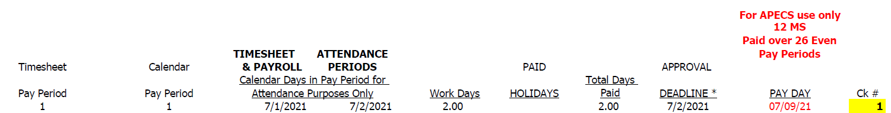

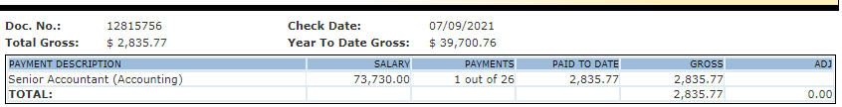
Final Pay Calculation for Terminated Salaried Employees
When a termination date is entered in the payroll system, the system calculates a pro-rated contract amount based on the days worked from the first workday of the contract year to the end date. This contract amount is computed by multiplying the daily rate (annual salary/number of workdays in a full year) by the days worked. The pro-rated contract amount is then compared to the paid to date amount and any balance due is paid on the next available pay date.

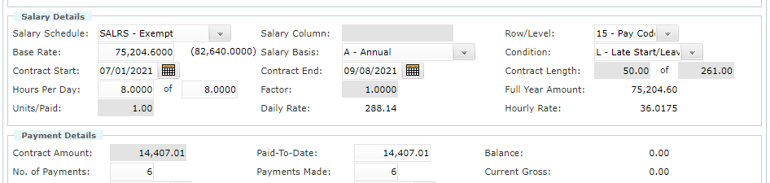

In the example above, this employee terminated on 9/8/2021. When the end date was entered, the system calculated a pro-rated contract amount by taking the daily rate of $288.14 and multiplying by the days worked from 7/1 – 9/8 (50) to get $14,407.01.
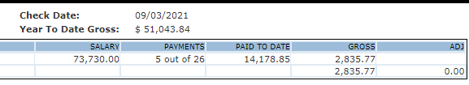
After the 9/3 payroll, this employee had a paid to date amount of $14,178.85 (see above). This employee would receive a final gross payment on 9/17 of $228.16.

