Create a Team
1. Select Teams > Join or create a team.
This is where you create your own team, or discover existing ones.
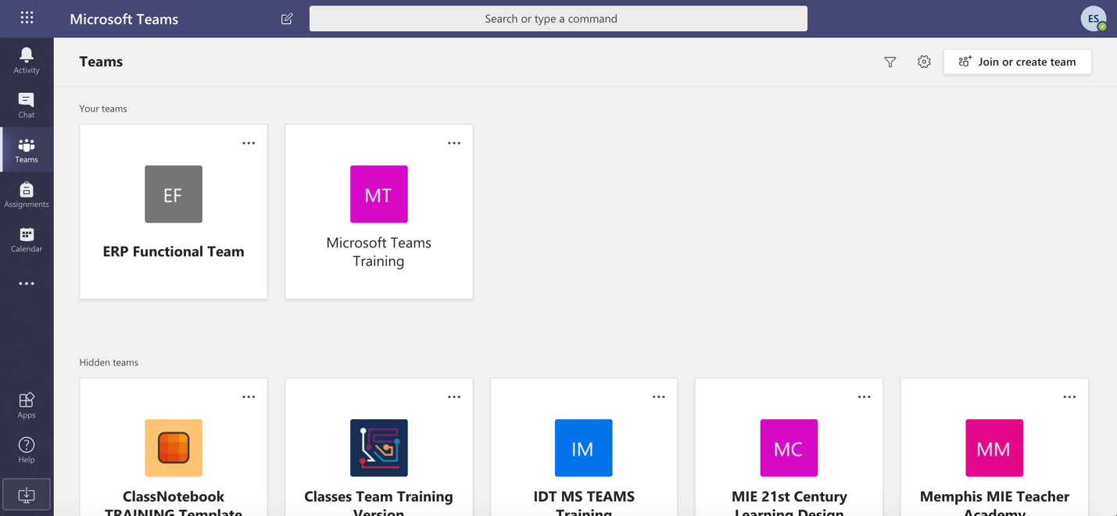
2. Select Create a new team, and then select Build a team from scratch or select Create from... to build an all-new team or create from an existing group respectively.
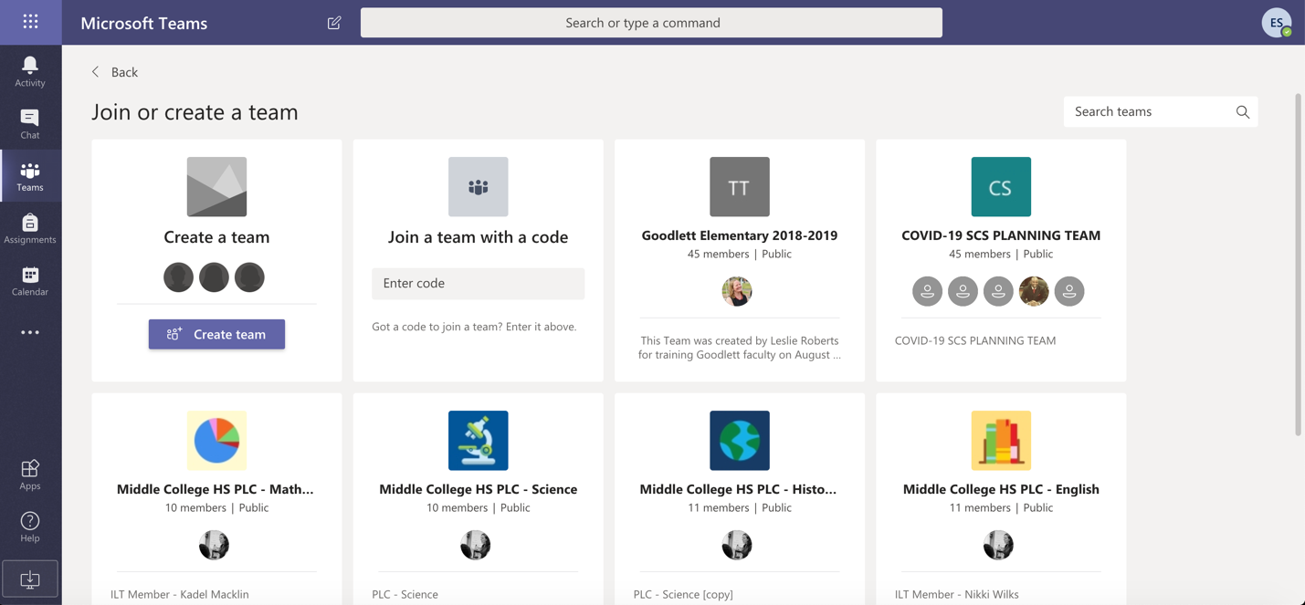
3. Select Private if you'd like people to request permission to join, or select Public if anyone in your org can join.
4. Give the team a name and add a short description if you'd like.
5. Select Create.
6. Add members.
You can add people, groups, or even entire contact groups.
7. When you're done adding members, select Add and then Close.

Create a Channel
By default, every team gets a General channel, which is a good channel to use for announcements and information the whole team needs. To add more channels:
1. Select More options... next to the team name.
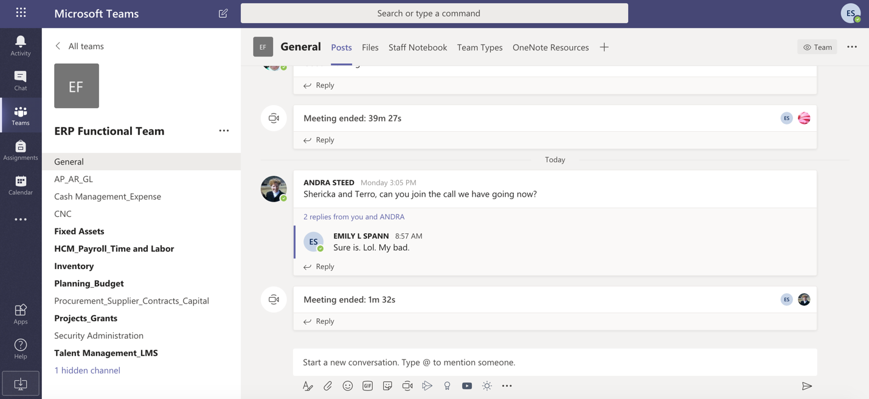
2. Select Add channel.
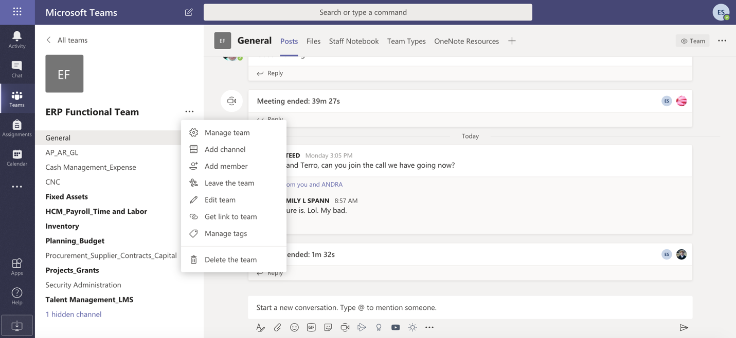
3. Enter a name and description for your channel.
You can build a channel around a topic, project, department name, or whatever you like.
4. Select Automatically show this channel in everyone's channel list if you want this channel to be automatically visible in everyone's channel list.
5. Select Add.
2-minute video tutorial – Creating a Team and a Channel
https://support.office.com/en-us/article/video-get-your-team-up-and-running-702a2977-e662-4038-bef5-bdf8ee47b17b?wt.mc_id=otc_microsoft_teams

