How to Access Teams

- 1. Using any web browser, log into your Office 365 account.

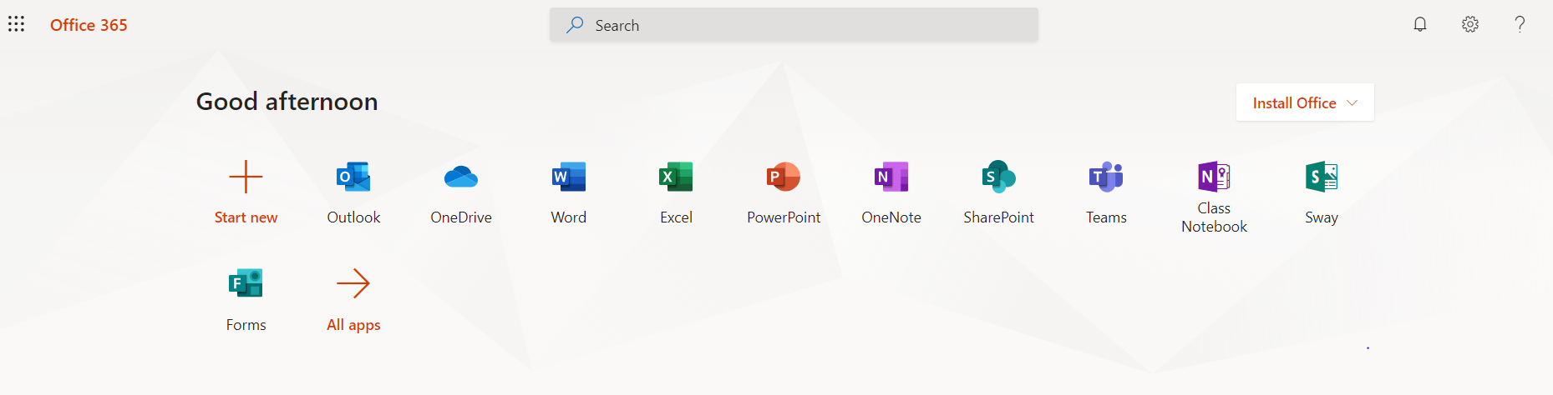

Optional: Use Edugoodies http://www.edugoodies.com/scs/

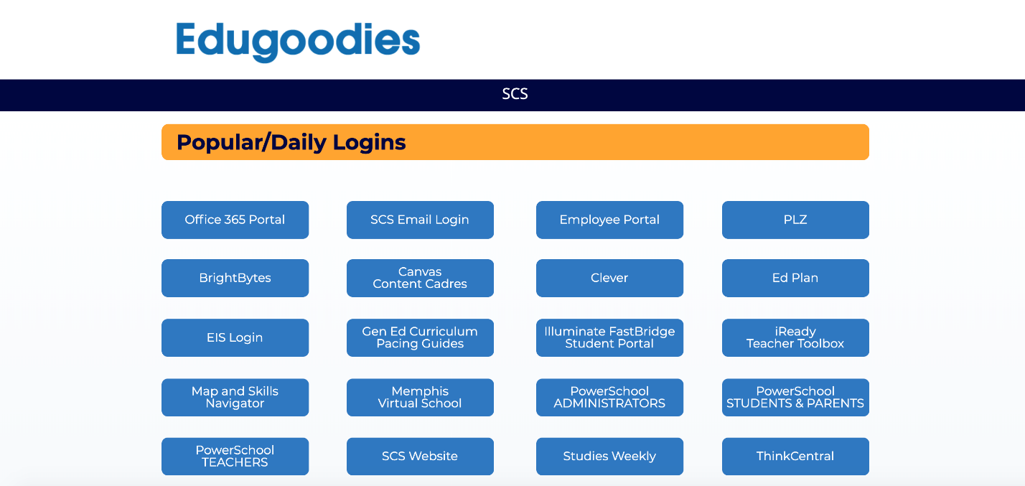

2. Click the grid in the upper-left hand corner of your email homepage to access all Office 365 apps.
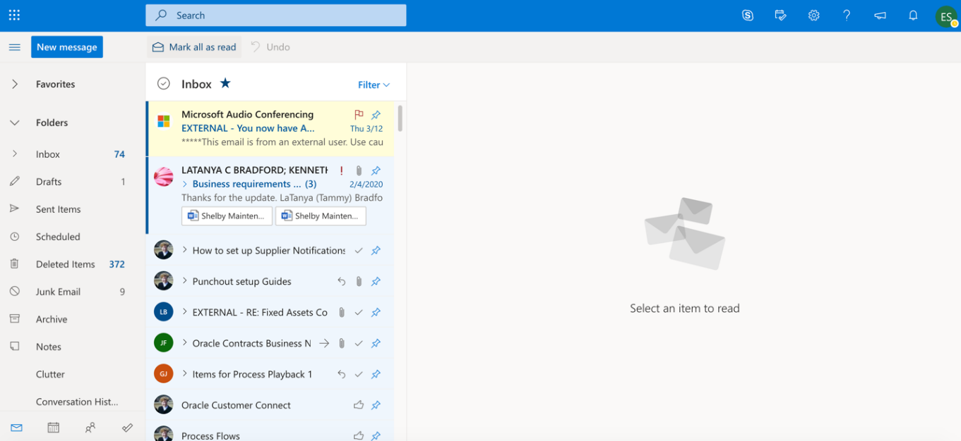

3. Click the Teams app. If it does not appear, click All apps to locate it.

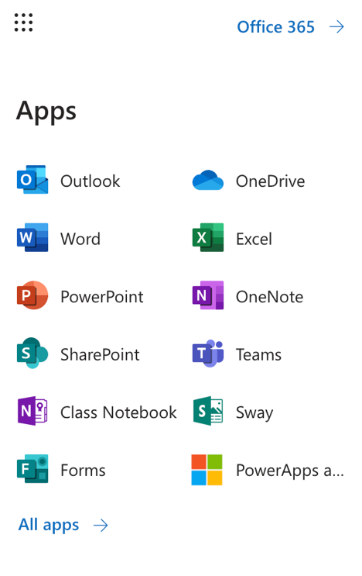

Download the Desktop App
You can us Teams online or by downloading the desktop app.

1. Log into Teams through your Office 365 Email account.
2. Click the download icon on your Teams homepage. If you get an error call the SCS Help Desk (901-416-2700) and they can install it for you.

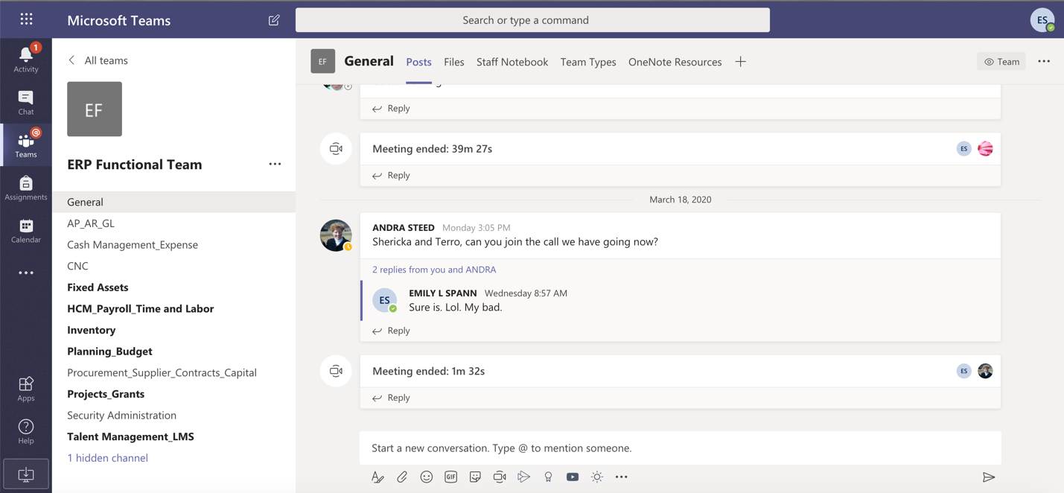

3. Follow the steps in the installations process.

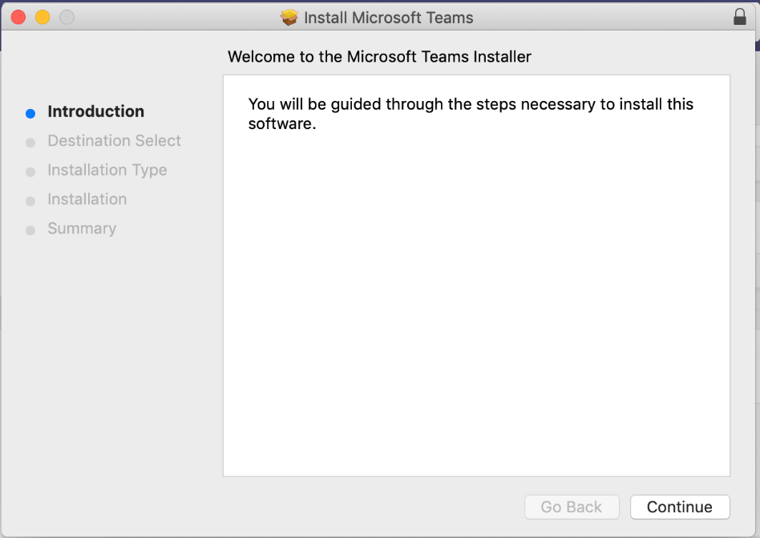

4. Begin using the Teams Desktop app.

