Join a meeting in Teams

Join by link
All you need to join a Teams meeting is a link.
Select Join Microsoft Teams Meeting in your meeting invite to be taken to a page where you can choose to either join on the web or download the desktop app. If you already have the Teams app, the meeting will open there automatically.

Join from calendar
Select Calendar on the left side of the Teams app to see your meetings. Find the meeting you want, and then select Join.
Or, if someone starts the meeting, you'll get a notification you can use to join.

Join in a channel
If a meeting takes place in a channel, you’ll see an invitation to join, relevant content, and who’s in the meeting right in the channel. Just select Join.
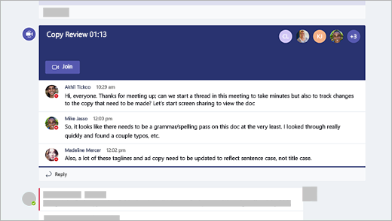

Join from chat
If the meeting has already begun, it appears in your recent chat list. Select the meeting in your chat list and then select Join at the top of the chat.

Call in
If you're unable to use the Teams app or Teams on the web, you can join some meetings by calling a phone number.
If there's a phone number and conference ID in the meeting invite, just dial the number to join.
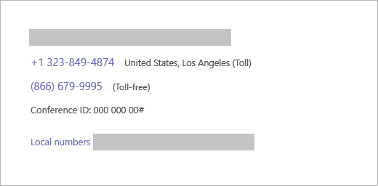
The number in your invitation may not be local to you. Select Local numbers to find one that is.

