TNReady Item Sampler (MICA)
The TNReady Item Sampler (hosted on a platform called MICA) provides a sample of every type of question that will be included on TNReady and can be accessed any time, from anywhere.
The purpose of MICA is to give educators access to questions like the questions on TNReady and to give students the opportunity to practice with the tools and system in every day instruction.
- The MICA website mimics MIST, so students can get familiar with the format of the test. MICA has the same accessibility and accommodation features as MIST, so students can practice with tools like highlighting.
- MICA is a collection of TNReady-like items; it is not a full practice test.
- MICA is a flexible tool for teacher use; you can create and assign assessments within the platform. It is not a secure testing platform.
- The Item Sampler (MICA) can be found here: https://micatime.com/
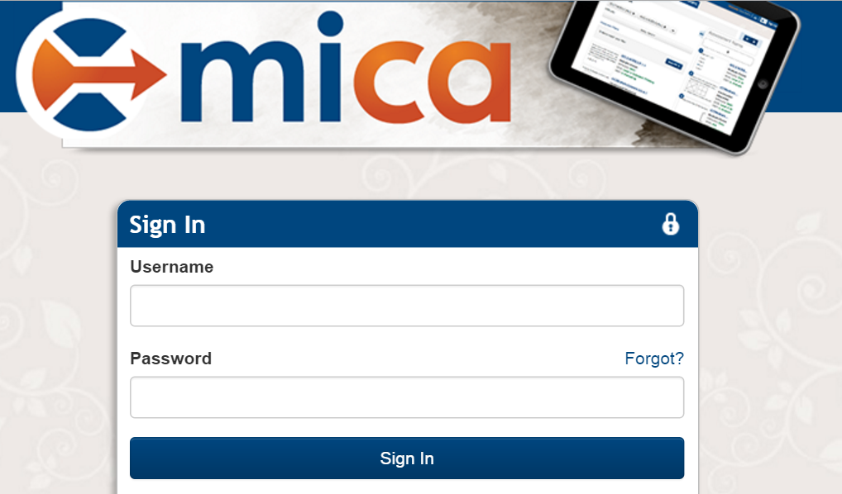
- If you have questions about your log-in, speak with your testing coordinator or contact the MICA team at support@micatime.com. Information about how to navigate MICA is available after you log in!
MICA is a genuinely flexible tool. Here are some different ways you could use MICA:
- Create a test to take personally or with a PLC to better understand expectations.
- Use problems as part of a larger unit assessment.
- Use questions in a center rotation, particularly technology or writing centers.
- Assign one question to the class to work on or discuss together.
- Create individualized quizzes targeting areas of student need.
- Create a quiz with other teachers in your grade and compare and analyze results together.
To learn more about the TNReady practice tools, visit:
- TDOE TNReady Practice Tools homepage: A summary of TNReady practice tools.
- Classroom Chronicles: Using MICA to prepare for TNReady: Hear how other teachers in TN are using MICA!

Using MICA: Information for ELA
Support for how to make quizzes and navigate MICA is available once you log in. If you have any questions, contact support@micatime.com.
As you work with TNReady practice items, there are a few assessment design resources that might be helpful:
- Ten Things to Know about TNReady from the TDOE
- TNReady Blueprints: Blueprints provide a summary of what will assessed in each grade, including the number of items that will address each standard on each part of TNReady. This webpage also includes the ELA writing rubrics that will be used to score students’ writing on the TNReady assessment.
- Descriptions of TNReady Writing Types: This document outlines the three types of writing expected by the standards and information about how they will be assessed on TNReady, including what types of passages will be used, what to expect from tasks, and examples of tasks.
- ELA Passage Specifications: This document is for test developers. You can reference it if you would like to see how passages are vetted to be included on TNReady.

