Daily Burn is a leading fitness tech brand dedicated to helping all people live better lives through movement. Daily Burn offers a popular, daily group class (Daily Burn 365) streamable to any device. In addition, access to a library of more than 1,000 on-demand workouts available and taught by certified trainers. Everything from cardio to Pilates to bodyweight training - Yoga, Running and more.

Daily Burn is Fitness Tech meets Social Motivation
- High value production quality
- Community is at the forefront of our offering
- Expert trainers who understand, guide and motivate our customers
- All Cigna® customers receive their first month free with a discounted subscription of $14.95/month + tax thereafter*

Audience Overview
- Sweet spot: women ages 18-45
- Geographically spread throughout the country
- Targeting the beginner fitness level

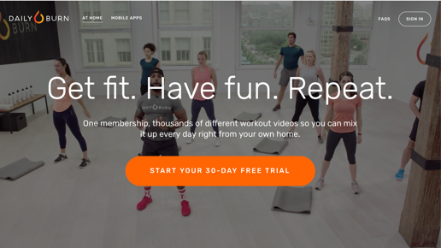
Content Summary
Daily Burn covers many types of fitness for any
fitness level including the most popular categories:
- High Intensity Interval Training (HIIT)
- Strength and Tone
- Meditation
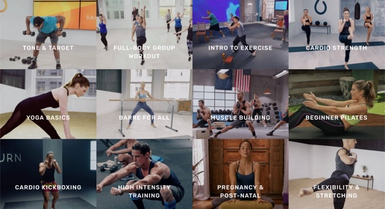
- Mobility
- Kickboxing
- Yoga, Pilates, Barre
- Running (treadmill and outdoor)
- Pre-Natal

Multi-Platform Distribution
*This discount program is separate from Cigna-administered benefits. A discount program is NOT insurance, and the customer must pay the entire discounted charge. Some programs are not available in all states and programs may be discontinued at any time. Daily Burn is solely responsible for its products and services and is not an affiliate of Cigna. All Cigna products and services are provided exclusively by or through operating subsidiaries of Cigna Corporation, including Cigna Health and Life Insurance Company or its affiliates. "Cigna" is a trademark of Cigna Intellectual Property, Inc.

